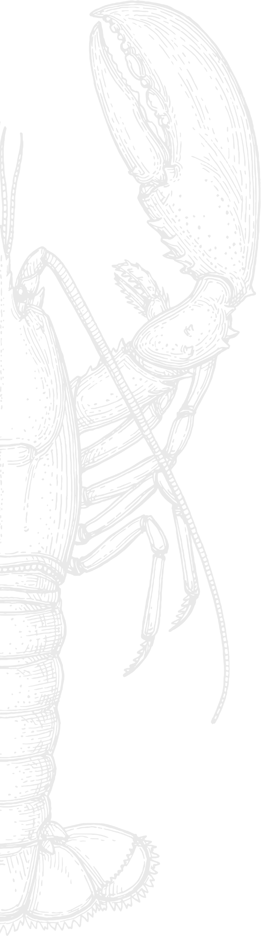
The culinary signature of our Chef...

- Exceptional products

First of all, lobster. A fine and firm flesh, a beautiful black colour with bluish reflections, so many characteristics that make the Breton lobster unique. Nicknamed "Prince of Brittany", "little blue" or "Lord of Breton waters", he is known for his extremely fine taste.

Finally, the Aquitaine Caviar from Maison Sturia – breeder, producer and refiner of caviar. The "Oscietra" selection melts under the tongue and gives off milky notes, olive oil and iodine aromas with a nice length in the mouth. Its grapes are creamy, with dark green reflections.

- A traditional cooking technique

To offer you a lobster dish with a flambéed taste, we opt for cooking over a wood fire, cooking the flesh on the barbecue. This method, rooted in our chef's African origins, adds an authentic dimension and distinct flavor to our grilled lobster.

- A unique piece of goldsmithing

Indeed, Le Pressoir d'Argent Gordon Ramsay takes its name from the extremely rare presence in its room of an imposing solid silver lobster press, made by Christofle in only six copies in the whole world. This collector's item continues to be used every night in front of customers to grind coral and carcasses to extract their juice from the blue lobsters.

- A multi-sensory gastronomic experience

This signature dish is a true emotional spectacle. In this velvet cocoon designed by Jacques Garcia, the customer has a front row seat to this gastronomic staging, this meticulous choreography where the senses are awakened one after the other, punctuated by the lyrical flight of the tasting.

... by Chef Alexandre Koa

An experience to discover with your menu for 70€ per person.

The culinary signature of our Chef...

- Exceptional products

First of all, lobster. A fine and firm flesh, a beautiful black colour with bluish reflections, so many characteristics that make the Breton lobster unique. Nicknamed "Prince of Brittany", "little blue" or "Lord of Breton waters", he is known for his extremely fine taste.

Finally, the Aquitaine Caviar from Maison Sturia – breeder, producer and refiner of caviar. The "Oscietra" selection melts under the tongue and gives off milky notes, olive oil and iodine aromas with a nice length in the mouth. Its grapes are creamy, with dark green reflections.

- A traditional cooking technique

To offer you a lobster dish with a flambéed taste, we opt for cooking over a wood fire, cooking the flesh on the barbecue. This method, rooted in our chef's African origins, adds an authentic dimension and distinct flavor to our grilled lobster.

- A unique piece of goldsmithing

Indeed, Le Pressoir d'Argent Gordon Ramsay takes its name from the extremely rare presence in its room of an imposing solid silver lobster press, made by Christofle in only six copies in the whole world. This collector's item continues to be used every night in front of customers to grind coral and carcasses to extract their juice from the blue lobsters.

- A multi-sensory gastronomic experience

This signature dish is a true emotional spectacle. In this velvet cocoon designed by Jacques Garcia, the customer has a front row seat to this gastronomic staging, this meticulous choreography where the senses are awakened one after the other, punctuated by the lyrical flight of the tasting.

... by Chef Alexandre Koa

An experience to discover with your menu.

